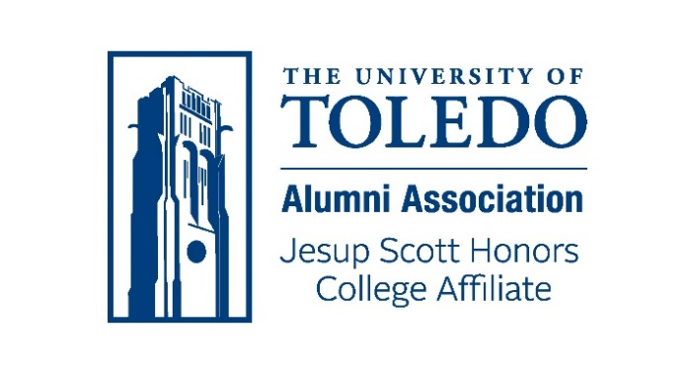
ANNUAL REPORT FOR 2025

The Jesup Scott Honors College Alumni Affiliate reorganized and became active again in late 2024. The Affiliate now has a complement of enthusiastic and engaged Board members who assumed their responsibilities at that time. Board officers were elected, and an Events Chair was appointed, in the spring of 2025.
Our Board members reside in Toledo and northwest Ohio, as well as Columbus and the states of Indiana, Connecticut and Virginia. Classes represented on the Board range from the 1960’s to the 2020’s. Board members bring with them a variety of career and special interest backgrounds.
Throughout 2025 we held monthly Webex Board meetings. In addition to the Board members, our meetings are attended by the Honors College Program Director, the Assistant Program Director, the Honors College Student Program Coordinator, and the Assistant Director of Alumni Engagement for our Affiliate. The Board Secretary maintains a complete set of meeting agendas and minutes.
The Honors College Alumni Affiliate is committed to developing and promoting engaging activities and events for our alumni and assisting the Honors College and its students in any ways we can. In 2025 our Board:
- Created and distributed to alumni a survey soliciting information as to the type, location and frequency of preferred alumni events
- Collaborated with the Student Program Coordinator and held a Flip the Table game afternoon with alumni and students – 31 participants
- Set up an Affiliate information table at Art on the Mall, and created an arts scavenger hunt for participants
- Participated in the Brews and Brews tour in downtown Toledo – 35 attendees
- Hosted a Homecoming luncheon for Honors alumni and students – 71 attendees
- Hosted a tent at the Homecoming parade
- Worked with the Honors College to develop a mentoring program for Honors students
- Participated in a Pre-Health Advisory Panel
- Held a virtual book club evening for alumni and students - 21 participants
- Board members attended Honors College Medallion Ceremonies for graduating seniors
- Board members participated in the University’s Day of Giving and contributed additional gifts to the Honors College
Attendees at this year’s events included alumni representing every decade of the Honors Program’s and Honors College’s existence. Our Board is proud of our accomplishments in 2025 and we are looking forward to continuing to serve the Honors College and alumni in 2026.
The Events Team is already beginning to plan 2026 activities. Responses to the alumni survey we sent out indicated significant interest in a variety of family-friendly activities, virtual networking opportunities and a virtual book club. Given that the virtual book club event we held with alumni and students in November was well attended and elicited a stimulating discussion, this is one of the activities we expect to pursue going forward. We also intend to emphasize service events in 2026. Additionally, as Honors College alumni are also alumni of one or more UToledo degree-granting Colleges, combined activities with other affiliates would appear to present fruitful opportunities for collaboration.

(s) Alan Lapp, President

Honors College Alumni Affiliate Board:
Alan Lapp, ’69, ’72 – President Nancy Collins, ’69, ‘74
Lucy Frank, ’17 - Secretary Wade Lee Smith, ‘93
Doug Rammel, ’90 - Treasurer Jessica Pellman, ‘09
Stacey Wisnieski, ’99 – Events Chair Valerie Collins, ‘92
Zach Dehm, ‘13
James Niekamp, ‘20

